Exact Concept-Grouped SHAP Explanations of a Deployed Real-Time PM2.5 Ensemble for Texas Census Tracts
Saketh Chebrolu  St. Mark's School of Texas  Dallas, TX, USA  chebrolusaketh@gmail.com | Nathan Tan  St. Mark's School of Texas  Dallas, TX, USA  nathantan2027@gmail.com | Yifeng Wang  School of Civil and Environmental Engineering  Georgia Institute of Technology  Atlanta, GA, USA  ywang3627@gatech.edu

Abstract—Fine particulate matter (PM2.5) is a leading environmental health risk, yet regulatory monitors are too sparse to resolve the concentration gradients that determine neighborhood-scale exposure, and the machine learning models that fill this gap are consulted operationally although aggregate skill metrics reveal nothing about where or why they fail. This paper presents the explanation layer of a publicly deployed system that maps 24-hour PM2.5 across all 6,896 Texas census tracts on a 30-minute cycle, fusing 310 quality-screened PurpleAir sensors with meteorological, wildfire-smoke, and atmospheric-composition data; the deployed convex tree ensemble over 30 features attains a leave-one-sensor-out coefficient of determination of 0.71. Blending per-model TreeExplainer attributions with the deployment weights reconstructs every pre-clipping prediction, with audited maximum error below 0.000007 micrograms per cubic meter, and an exhaustive partition of the features into five concept groups renders each prediction in physical units. Attribution identifies the system as a spatial nowcaster: same-day neighboring sensors contribute 4.82 micrograms per cubic meter of mean absolute attribution, against 0.47 for geography, 0.25 for meteorology, and 0.09 for the dedicated smoke tier. Removing all eight demographic and source-proximity inputs cost no measurable accuracy, yet the same neighbor features structurally suppress hyper-local events: across 46 training episodes above 40 micrograms per cubic meter in which every neighbor mean was below 5, the regional term was negative in all 46 and no prediction exceeded 8.5. Exact explanations convert a validated black box into an operational diagnostic that identifies not only what the map resolves but where it cannot.
Index Terms—explainable artificial intelligence, SHAP, air quality, PM2.5, low-cost sensors, ensemble learning, environmental monitoring
I. Introduction
Regulatory PM2.5 monitoring is sparse relative to the spatial variability of urban exposure. Low-cost networks such as PurpleAir report fine particulate matter (PM2.5) at neighborhood scale and minute cadence, and corrected versions of their data feed public tools such as the AirNow Fire and Smoke Map [1]. Sensor placement is itself uneven across income groups [2]; for many communities, models interpolating between sensors are the sole source of air quality information.
Such models are evaluated almost exclusively by aggregate accuracy, which can conceal behavior their operators would not endorse; when outputs color a public map or guide monitor placement, unexamined behavior is an operational risk. Shapley additive explanation (SHAP) methods [3], [4] have made attribution tractable for tree models, and environmental applications such as flood-susceptibility mapping have begun to adopt them [5]. Published explanations, however, almost invariably concern research models; deployed systems remain unexamined.
This paper provides an exact explanation of one deployed system: a live web platform that predicts PM2.5 for every Texas census tract from PurpleAir sensors and public data streams. The contributions are threefold: (1) an exact explanation layer for the deployed convex tree ensemble, in which per-model TreeExplainer attributions blended with the deployment weights reconstruct every pre-clipping output to machine precision, and a partition of the 30 features into five concept groups expresses each prediction in physical units; (2) a characterization of the deployed model as a spatial nowcaster dominated, to a degree aggregate metrics do not reveal, by same-day readings from neighboring sensors; and (3) an explanation-driven failure analysis demonstrating that the neighbor features responsible for the model's accuracy actively suppress its predictions during hyper-local pollution events, a structural limitation that motivates targeted sensor placement rather than model tuning.
II. The Deployed System

A. Platform
The platform serves a public, bilingual web map of model-estimated 24-hour PM2.5 for all 6,896 Texas census tracts, public since April 2026. The backend retrieves live PurpleAir readings, cached for 15 minutes, recomputes the full feature set, runs the ensemble for every tract, and caches predictions for 30 minutes. A served value estimates a tract's daily-mean-equivalent PM2.5 under current conditions; the training pipeline is reproduced at serving time, so sub-daily dynamics enter only through the inputs. The tract color scale breaks at 9 μg/m³, the 2024 annual PM2.5 standard [6], as a fixed reference for the 24-hour map. A second view proposes future sensor placements, to which Section V returns.
B. Training data and features
The training target is the daily mean of the raw PurpleAir ATM-channel PM2.5 concentration. Readings are restricted to 0 to 200 μg/m³ and cleaned per sensor with a robust z-score rule on median absolute deviation; sensors with fewer than 60 valid days, near-constant output, or medians indicating indoor placement are excluded. The corpus comprises 285,798 daily readings from 310 outdoor Texas sensors between January 2021 and May 2026. Sensors in border states contribute same-day neighbor context but are never training targets. The raw ATM channel is retained, rather than corrected [1], so that training targets and live inference share semantics; Section V revisits this choice. Days with means above 75 μg/m³ are excluded from training, a decision the explanations quantify.
Each row carries 30 features (Table I): daily weather from Open-Meteo [7]; same-day neighbor statistics (mean and count of other sensors within 25, 50, and 100 km, plus dispersion at 50 km, computed with a haversine BallTree); an ordinal smoke tier from NOAA Hazard Mapping System (HMS) analyst polygons [8]; aerosol optical depth and surface PM2.5 from the Copernicus Atmosphere Monitoring Service (CAMS) [9]; location and distance covariates; and calendar encodings.
No EPA EJScreen variable is a model input. An earlier deployment carried eight (four demographic and four source-proximity) accounting for 12.1% of blended attribution [10]; all eight were removed before this study, because a model used to characterize exposure disparities must not receive those groups as predictors, or any disparity it reproduces is partly an artifact of its own inputs. Removal cost was measured on frozen sensor-grouped folds with the blend held fixed: dropping the four demographic features changes Δ R² = 0.0022 (95% CI [-0.0031,+0.0083]) and dropping all eight -0.0005 ([-0.0070,+0.0066]); both intervals contain zero, and the negative sign indicates the smaller model scored marginally higher.
C. Ensemble and validation
Four regressors are trained: a random forest [11], LightGBM [12], XGBoost [13], and CatBoost [14]. Validation is leave-one-sensor-out (LOSO): each of the 310 sensors is held out in turn, models are refit on the remainder, and the neighbor features of every training row are recomputed with the held-out sensor removed, closing a same-day leakage path that random splits cannot detect. Spatially naive cross-validation is known to overstate the skill of models of this class [15]; under random 80/20 splitting this ensemble scores R²=0.80, which LOSO deflates to 0.71. LightGBM and XGBoost use Huber and pseudo-Huber objectives respectively: PM2.5 is heavy-tailed, and squared error lets a few smoke and dust days dominate the fit.
Blend weights are a simplex-constrained convex combination fit on the LOSO out-of-fold predictions and selected by a grouped cross-fit over sensors. The deployed weights are 0.7935 (random forest), 0.1363 (CatBoost), 0.0702 (LightGBM), and exactly zero for XGBoost, giving LOSO R²=0.7134 against 0.7084 for an equal-weight blend and 0.7090 for an inverse-MSE baseline. The deployed configuration scores RMSE 4.21 μg/m³ and MAE 2.61 μg/m³. The random forest alone reaches 0.7138: the leading candidates are tied at this resolution, and the deployment is a nearly single-model instance of the convex blends the method covers; the blend is explained because the blend is deployed. Live inference imputes unavailable features with training medians.
TABLE I
The five concept groups partitioning the 30 model features (group sizes in parentheses).
Group | Features
Regional PM signal (9) | neighbor PM2.5 mean and count at 25, 50, 100 km; dispersion at 50 km; CAMS AOD; CAMS PM2.5
Wildfire smoke (1) | HMS smoke tier (none/light/medium/heavy)
Meteorology (7) | temperature, humidity, pressure, wind speed, precipitation, two interaction terms
Geography (4) | latitude, longitude, distance to coast, distance to nearest sensor
Season and calendar (9) | month, weekday, day of year, and their sine/cosine encodings

III. Exact Ensemble Explanations
A. Blending per-model attributions
The deployed prediction for features x is f(x)=max(0,Σ_{m} w_{m} f_{m}(x)) over the three models with w_{m}>0. TreeExplainer [4] decomposes each tree model exactly as f_{m}(x)=b_{m}+Σ_{j} φ^{m}_{j}(x). Attributions are additive, so
Σ_{m} w_{m} f_{m}(x) = b + Σ_{j} φ_{j}(x), (1)
where b=Σ_{m} w_{m} b_{m} and φ_{j}(x)=Σ_{m} w_{m} φ^{m}_{j}(x). The result is an additive decomposition of the pre-clipping ensemble output, computed without sampling or surrogate models. The algebra follows immediately from the additivity of SHAP attributions [3]; its value lies in applying it to the ensemble a public platform serves. Exactness denotes local accuracy, faithful reconstruction of this model's output, not axiomatic Shapley values under an interventional distribution: TreeExplainer (SHAP 0.50.0) runs in tree-path-dependent mode, conditioning on the training distribution through tree cover counts, so credit assignment among correlated features differs from interventional variants. The audit of Eq. (1) executes wherever rows are explained. Over the 6,000-row global sample the maximum absolute reconstruction error is below 7×10⁻⁶ μg/m³; the residual reflects float32 caching, and direct float64 explanation of individual rows reconstructs to 5×10⁻¹⁴ μg/m³. The serving layer applies only a final clip at zero, which never binds on the sampled predictions (minimum raw output +0.4 μg/m³).
B. Concept groups
Individual attributions for 30 features are exact but not interpretable by a public audience. The features are therefore partitioned into the five concept groups of Table I, and group sums Φ_{G}(x)=Σ_{j∈ G}φ_{j}(x) are reported, the summation form of grouped Shapley explanation [16]; the contribution is the ontology, not the operation. Because the partition is exhaustive and disjoint, b+Σ_{G} Φ_{G}(x) reconstructs the prediction exactly, and runtime validation asserts the partition against the deployed feature list. A group's global importance, the mean absolute summed contribution, falls below the sum of member importances when members cancel.
C. Analysis protocol
Global structure is computed over a uniform 6,000-row sample of the training frame (seed 42). Feature response is analyzed with dependence scatters, 12-quantile binned medians, and Spearman rank correlations between feature value and attribution, with bootstrap intervals clustered by sensor. Because the sample contains only five heavy-smoke rows, tier-level smoke statistics are recomputed exactly over all 431 heavy-tier corpus rows and a 2,500-row medium-tier sample, with 2,000-resample percentile-bootstrap 95% confidence intervals clustered by day, because statewide plumes correlate same-day rows. Two full days are explained sensor-by-sensor: the strongest smoke day (May 27, 2024) and the cleanest day (April 3, 2024) among days with at least 150 reporting sensors. Local cases follow fixed selection rules: the highest-reading smoke-day row predicted within 35% of its observation, and the worst underprediction above 40 μg/m³. All pipeline outputs reproduce byte-identically; every analysis number is regenerated by verification scripts released with the code.
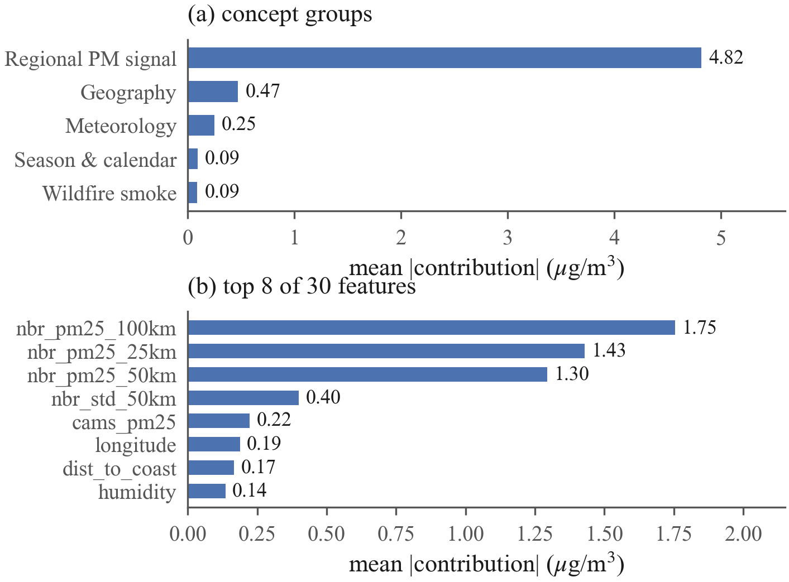
Fig. 1. Global importance over the 6,000-row sample. (a) Mean absolute concept-group contribution; the regional PM signal exceeds every other group by an order of magnitude. (b) The top individual features are the three neighbor means, neighbor dispersion, and CAMS surface PM2.5.
IV. Results
A. The model is a spatial nowcaster
Fig. 1 shows global importance. The regional PM signal group averages 4.82 μg/m³ of absolute contribution per prediction (95% CI [4.71,4.93]); the next group, geography, averages 0.47 μg/m³ [0.41,0.53], an order of magnitude smaller, followed by meteorology at 0.25 μg/m³, season and calendar at 0.091 μg/m³, and the dedicated smoke tier last at 0.090 μg/m³. The three neighbor-mean features are individually the three most important inputs (1.75, 1.43, and 1.30 μg/m³ at 100, 25, and 50 km). The ensemble's predictions are, before all else, spatial averages of what nearby sensors currently report.
The top of the ordering is unambiguous: the regional group's interval is disjoint from every other, and grouped permutation importance reproduces the ranking exactly (rank correlation 1.0). The full five-way ranking survives 65.8% of 1,000 sensor-clustered resamples, with the instability confined to the bottom pair: season (0.091) and smoke (0.090) differ by 0.001 μg/m³, so their order is not resolved.

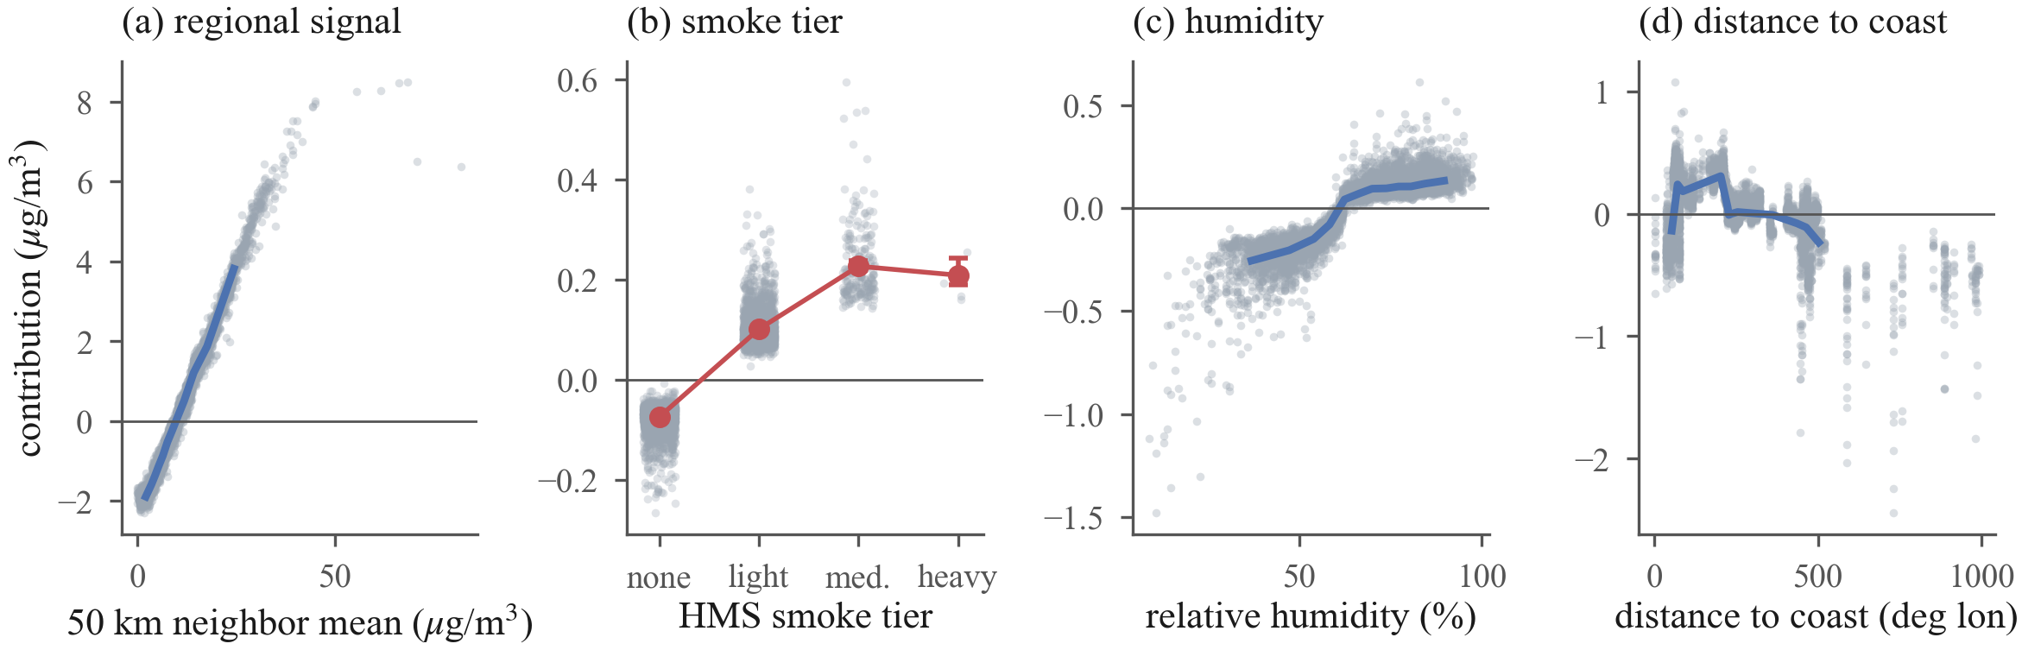
Fig. 2. Feature dependence on the 6,000-row sample (gray points; blue line is the 12-quantile binned median). (a) Contribution of the 50 km neighbor mean is near-linear then flattens above 40 μg/m³. (b) HMS smoke tier: red markers are exact means over all 431 heavy-tier rows and 2,500 medium-tier rows with day-clustered bootstrap 95% intervals; the heavy tier shows no increase over medium. (c) Humidity contributes weakly but monotonically, with a threshold near 60% RH. (d) Distance to coast trends negative inland, encoding the Gulf moisture gradient and sensor-network density rather than a causal effect of position.

B. Feature response and semantics
Dependence analysis (Fig. 2) yields four findings.
1) Near-linear regional response: The 50 km neighbor mean maps onto its attribution almost monotonically (Spearman ρ=0.993), with slope 0.25 μg/m³ per 1 μg/m³ of neighbor mean below 30 μg/m³, then flattens: over corpus rows, the median contribution is +5.78 μg/m³ for neighbor means between 30 and 40 μg/m³ (2,000 of 4,060 rows sampled) and +7.39 μg/m³ (CI [7.37, 7.43], all 860 qualifying rows) above 40 μg/m³. The flattening is consistent with the exclusion of training days above 75 μg/m³: the model has no basis to extrapolate beyond its training range.
2) The smoke tier is nearly redundant: Mean attribution of the HMS tier, in μg/m³, is -0.074 (none) and +0.101 (light) on the sample, +0.227 over 2,500 recomputed medium-tier rows (day-clustered CI [0.218, 0.238]), and +0.209 over all 431 heavy-tier rows (CI [0.191, 0.243]; the heavy rows fall on only 31 days). Heavy-tier attribution shows no increase over medium (difference CI [-0.018, 0.041] μg/m³), and the entire tier range is negligible against a LOSO RMSE near 4.2 μg/m³. Only 431 of 285,798 training rows (0.15%) carry the heavy tier, and on those rows mean observed PM2.5 is lower than on medium-tier rows (11.6 versus 16.6 μg/m³): an analyst-drawn plume overhead does not guarantee surface-level smoke. The model largely disregards a feature whose evidential value its training data did not support.
3) The disparity survives the exclusion: Correlating tract predictions (6,896 tracts, 365 days) post hoc against EJScreen percentiles the model never receives, low income rises monotonically across quintiles from 8.58 to 9.29 μg/m³ (ρ=0.16); percent people of color is non-monotone, dipping to 8.67 mid-range before reaching 9.38. The disparity is real but non-uniform and, absent demographic inputs, is inferred from atmospheric evidence alone.
4) Interactions remain within the regional group: SHAP interaction values (a 400-row subsample, seed 42; random forest and CatBoost blended with renormalized weights covering 93% of the deployed ensemble, LightGBM omitted because its interaction runtime exceeded budget) rank the six leading pairs entirely within the regional signal group: the three neighbor means interact at 0.48, 0.41, and 0.30 μg/m³ mean absolute strength, followed by three neighbor-dispersion pairs. The strongest cross-group pair, humidity with the 100 km neighbor mean, is weaker at 0.06 μg/m³. Regional dominance is therefore not an artifact of additive attribution. Magnitudes are taken after the signed blend, so model disagreement cannot inflate a pair.
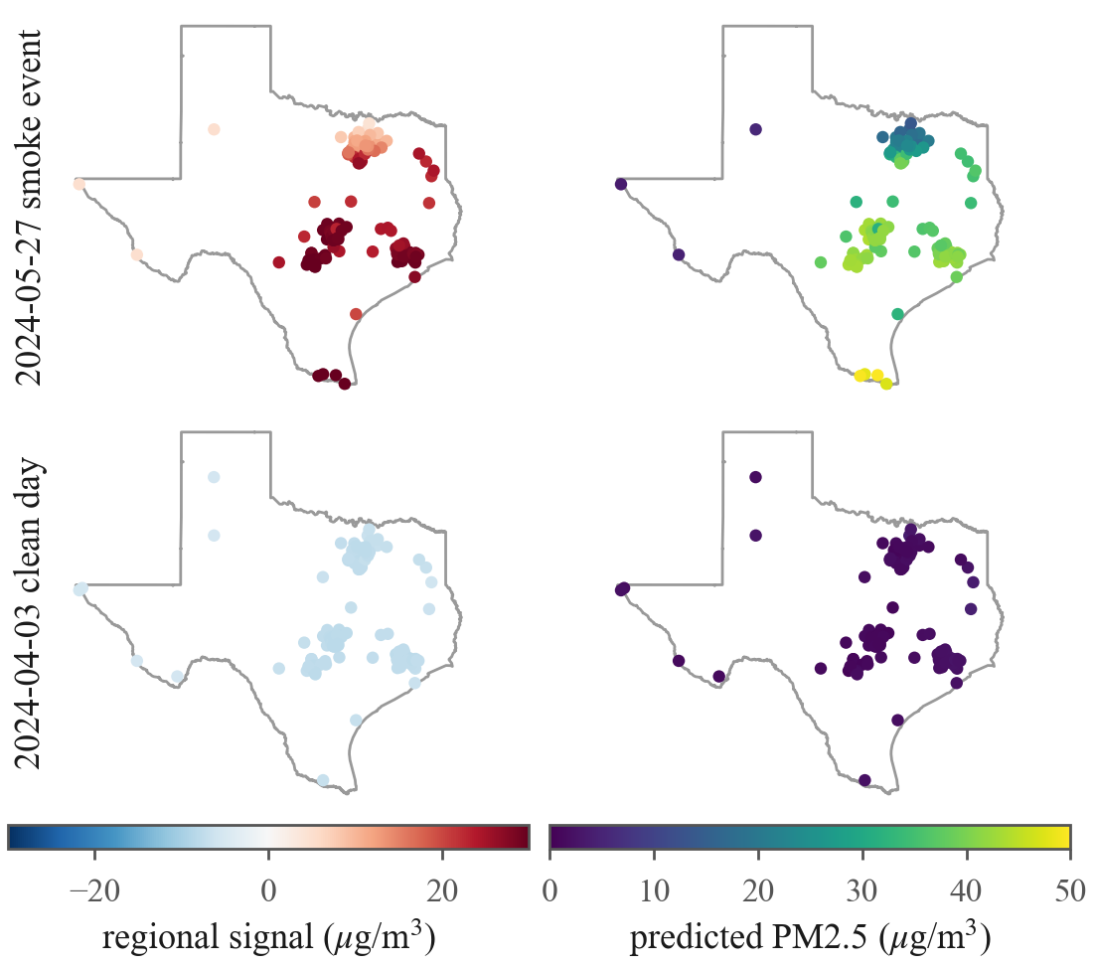
Fig. 3. Every reporting sensor explained on the strongest smoke day (top, 156 sensors, 98.7% under a plume) and the cleanest day (bottom, 154 sensors): regional-signal contribution (left) and predicted PM2.5 (right). The event is carried almost entirely by the regional signal (+24.3 μg/m³ statewide mean) while the smoke tier peaks at +0.64 μg/m³ anywhere in the state.
C. Contrasting days, one mechanism
On May 27, 2024 (Fig. 3), with 98.7% of sensors under an analyst-drawn plume and a statewide mean reading of 37.0 μg/m³, the model predicted a mean of 36.0 μg/m³, of which the regional signal group contributed +24.3 μg/m³ on average; the smoke tier's mean contribution that day was +0.4 μg/m³. On April 3, 2024 (statewide mean 1.03 μg/m³), the regional group lowered predictions by 7.6 μg/m³ on average from the 9.65 μg/m³ baseline. Smoke information reaches the model through the neighbor network rather than the smoke feature: both days instantiate the same nowcasting mechanism.
D. Case analysis: a detection and a miss
Fig. 4 decomposes two individual predictions. On the smoke day, sensor 217461 read 71.1 μg/m³ and the model predicted 49.8 μg/m³, with +34.6 μg/m³ from the regional signal and +0.64 μg/m³ from the smoke tier; even this detection underpredicts, consistent with the capped training range and the saturating neighbor response. On November 19, 2024, sensor 242357 read 75.0 μg/m³, at the retention boundary itself, while every neighbor mean sat below 1.8 μg/m³; the model predicted 5.1 μg/m³. The explanation is direct: the regional group contributed -5.9 μg/m³, with the 100 km neighbor mean alone at -2.2 μg/m³. The case is not isolated: 46 corpus rows read at least 40 μg/m³ with every neighbor mean below 5 μg/m³; the regional group is negative on all 46 (mean -4.9 μg/m³), and the highest prediction among them is 8.5 μg/m³ against a mean observation of 54.1 μg/m³. Rows above 75 μg/m³ were excluded before training (241 pre-cap), so these figures lower-bound the blind spot. The features that make the model accurate on regional events actively vote against hyper-local ones; no reweighting of the same features can recover what the network does not observe.
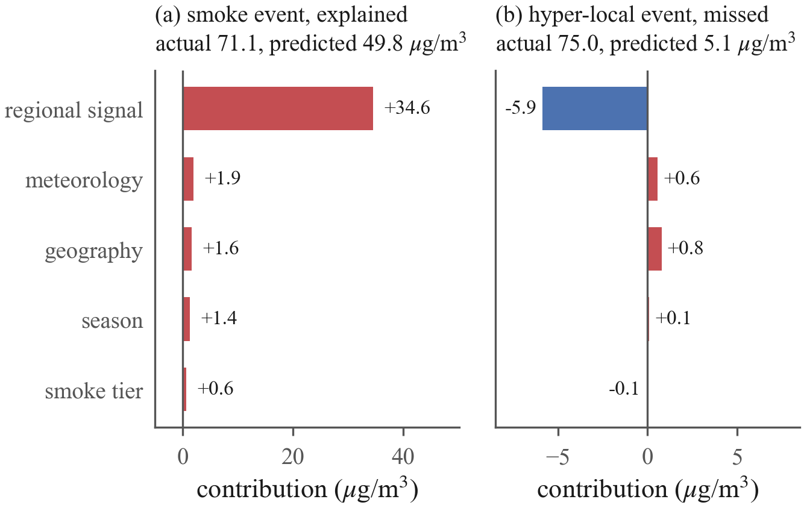
Fig. 4. Exact concept-group decomposition of two predictions. (a) A detected smoke event is carried by the regional signal; the smoke tier adds +0.6 μg/m³. (b) The worst miss in the corpus: neighbors observed nothing, and the regional signal suppresses the prediction below the baseline.
V. Discussion

A. Model development
The smoke tier warrants replacement rather than retuning: candidate representations include plume density, smoke age, and lagged fire radiative power. The saturating neighbor response follows from the 75 μg/m³ training cap; raising the cap is a measurable next experiment.
B. Network operation
The miss case converts an error metric into a map, subject to one caution: sign alone cannot separate clean surroundings from unobserved ones (the clean day's statewide mean regional contribution, -7.6 μg/m³, is as negative as El Paso's annual -6.8 μg/m³). Sparsity separates them: the El Paso sensor averages 0.8 same-day neighbors within 50 km against a statewide 27, and its regional contribution averages -6.8 μg/m³ against East Texas's +1.34 μg/m³ (up to +9.4). Persistently negative regional means in sparse neighborhoods mark locations where predictions rest on remote evidence (distance to the nearest sensor reaches 164 km), and these are where the platform's placement optimizer should allocate new sensors; the explanation layer supplies this prioritization directly.
C. Communicating attributions
SHAP explains the model, not the atmosphere. Distance to coast and longitude are the clearest example: both carry real signal, but they encode sensor-network position and the Gulf moisture gradient, not a causal effect of coordinates. Public-facing deployment of these explanations requires the concept-group framing and an explicit correlational disclaimer as defaults, not footnotes. Carrying no demographic input (Section II) removes the most severe misreading risk but does not make the remaining attributions causal.
D. Limitations
The target is the uncorrected ATM channel, so absolute levels are not comparable to regulatory monitors without a correction such as that of Barkjohn et al. [1], and the explanations inherit whatever bias that channel carries. Days above 75 μg/m³ are absent from training, so extreme-event behavior describes a model that never observed the worst days, and the failure analysis lower-bounds the blind spot. LOSO R² characterizes held-out sensor locations; accuracy at unsensed tracts is unquantified, and the miss case indicates it degrades precisely there. Every attribution is conditioned on a network whose placement is itself demographically uneven [2]: the regional-signal group is strongest where sensors are dense, so the explanations describe an unevenly observed state. Tree-path-dependent attribution spreads credit among correlated features, so within-group rankings are less certain than group totals. Explanation statistics describe the training frame, not the serving distribution. The findings describe one model, one state, and five years; the method applies to any convex blend of tree models.
VI. Conclusion
This work converted a deployed, accuracy-validated PM2.5 mapping system into one whose every prediction can be read: an exact blend of per-model TreeExplainer attributions, folded into five concept groups, reconstructs each output to machine precision. The resulting characterization is in part unfavorable: the model is a spatial nowcaster that largely disregards its smoke tier, uses geography as a proxy for network density, and cannot detect events its network does not observe. None of these properties is visible in R², and all of them bear on how the tool should be used, improved, and communicated. Explaining 6,000 predictions requires under six minutes on a desktop CPU, and a single prediction a fraction of a second; integrating exact, narrated explanations into the live platform is the immediate next step.
References
[1] K. K. Barkjohn, B. Gantt, and A. L. Clements, “Development and application of a United States-wide correction for PM_{2.5} data collected with the PurpleAir sensor,” Atmospheric Measurement Techniques, vol. 14, no. 6, pp. 4617–4637, 2021.
[2] P. deSouza and P. L. Kinney, “On the distribution of low-cost PM2.5 sensors in the US: demographic and air quality associations,” Journal of Exposure Science & Environmental Epidemiology, vol. 31, no. 3, pp. 514–524, 2021.
[3] S. M. Lundberg and S.-I. Lee, “A unified approach to interpreting model predictions,” in Advances in Neural Information Processing Systems 30, 2017, pp. 4765–4774.
[4] S. M. Lundberg et al., “From local explanations to global understanding with explainable AI for trees,” Nature Machine Intelligence, vol. 2, no. 1, pp. 56–67, 2020.
[5] B. Choubin, A. Jaafari, J. Henareh, O. Karimi, and F. Sajedi Hosseini, “Explainable artificial intelligence (XAI) for interpreting predictive models and key variables in flood susceptibility,” Results in Engineering, vol. 27, p. 105976, 2025.
[6] U.S. Environmental Protection Agency, “Reconsideration of the National Ambient Air Quality Standards for Particulate Matter; final rule,” Federal Register, vol. 89, p. 16202, Mar. 6, 2024, effective May 6, 2024.
[7] P. Zippenfenig, “Open-Meteo.com weather API,” Zenodo, 2023, computer software.
[8] S. J. Brey, M. Ruminski, S. A. Atwood, and E. V. Fischer, “Connecting smoke plumes to sources using Hazard Mapping System (HMS) smoke and fire location data over North America,” Atmospheric Chemistry and Physics, vol. 18, no. 3, pp. 1745–1761, 2018.
[9] V.-H. Peuch et al., “The Copernicus Atmosphere Monitoring Service: From research to operations,” Bulletin of the American Meteorological Society, vol. 103, no. 12, pp. E2650–E2668, 2022.
[10] U.S. Environmental Protection Agency, “EJScreen technical documentation for version 2.3,” U.S. EPA Office of Environmental Justice and External Civil Rights, Washington, DC, Tech. Rep., Jul. 2024, archived EPA snapshot of Jan. 19, 2025. [Online]. Available: https://19january2025snapshot.epa.gov/system/files/documents/2024-07/ejscreen-tech-doc-version-2-3.pdf
[11] L. Breiman, “Random forests,” Machine Learning, vol. 45, no. 1, pp. 5–32, Oct. 2001.
[12] G. Ke et al., “LightGBM: A highly efficient gradient boosting decision tree,” in Advances in Neural Information Processing Systems 30, 2017, pp. 3146–3154.
[13] T. Chen and C. Guestrin, “XGBoost: A scalable tree boosting system,” in Proceedings of the 22nd ACM SIGKDD International Conference on Knowledge Discovery and Data Mining. ACM, 2016, pp. 785–794.
[14] L. Prokhorenkova, G. Gusev, A. Vorobev, A. V. Dorogush, and A. Gulin, “CatBoost: unbiased boosting with categorical features,” in Advances in Neural Information Processing Systems 31 (NeurIPS 2018), 2018, pp. 6639–6649.
[15] H. Meyer and E. Pebesma, “Machine learning-based global maps of ecological variables and the challenge of assessing them,” Nature Communications, vol. 13, no. 1, p. 2208, 2022.
[16] M. Jullum, A. Redelmeier, and K. Aas, “groupShapley: Efficient prediction explanation with Shapley values for feature groups,” arXiv:2106.12228, 2021.

